**Enable the Delete Confirmation Dialog Box in Windows 10 using Registry Editor**

1. Locate the Registry Editor by typing “regedit” into the Windows search bar. Either hit the enter key or click **Open** to launch it:

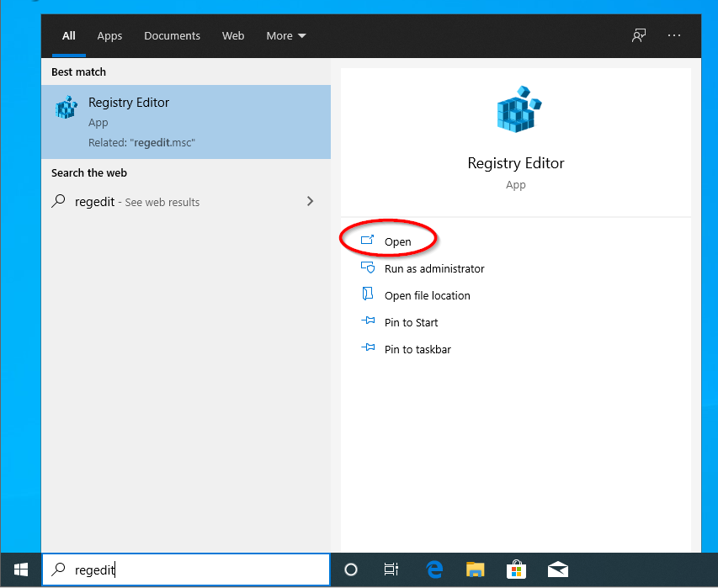

1. Click **Yes** when prompted by the User Account Control pop-up:

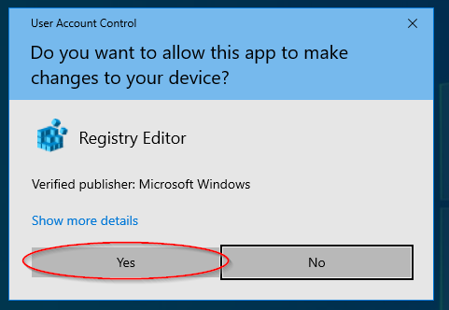

1. Double-click on the folder named **HKEY_CURRENT_USER:**

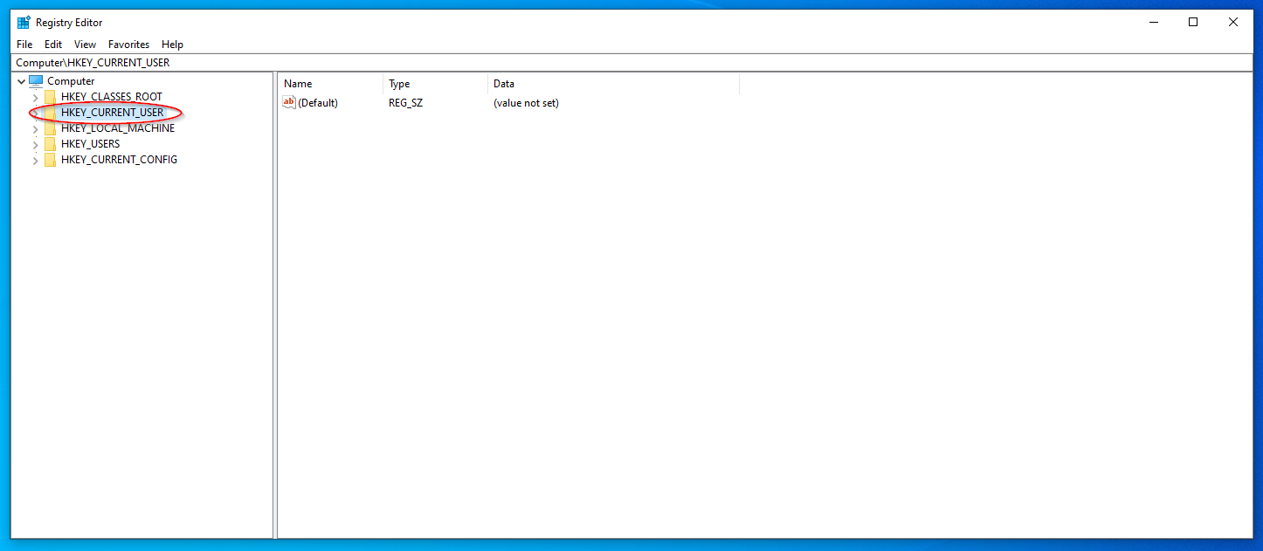

1. From inside this folder, we are going to open (double-click) on six more folders in the following order:

**SOFTWARE** 🡪 **Microsoft** 🡪 **Windows** 🡪 **CurrentVersion 🡪 Policies 🡪 Explorer**

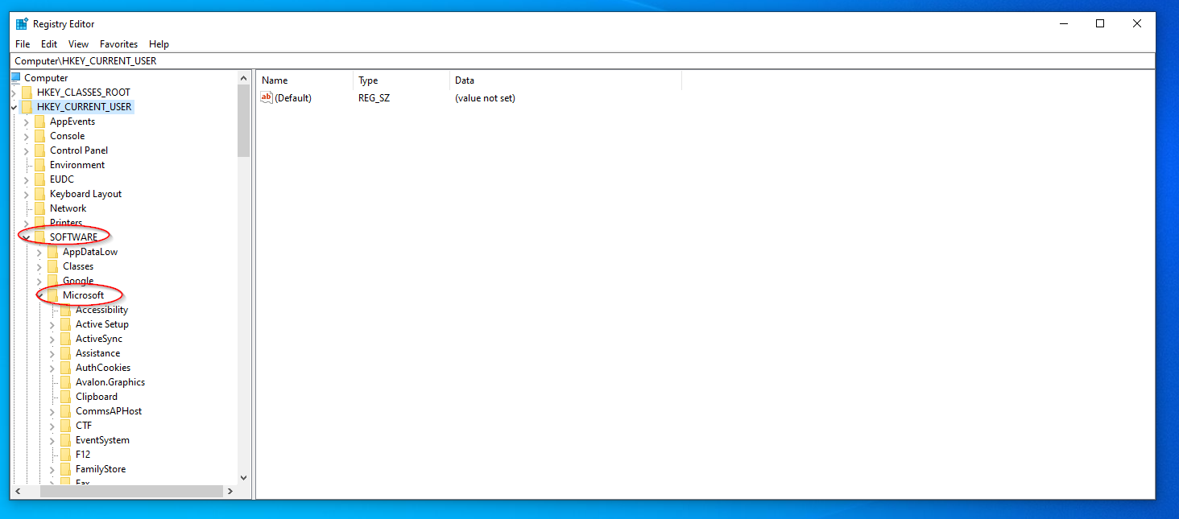

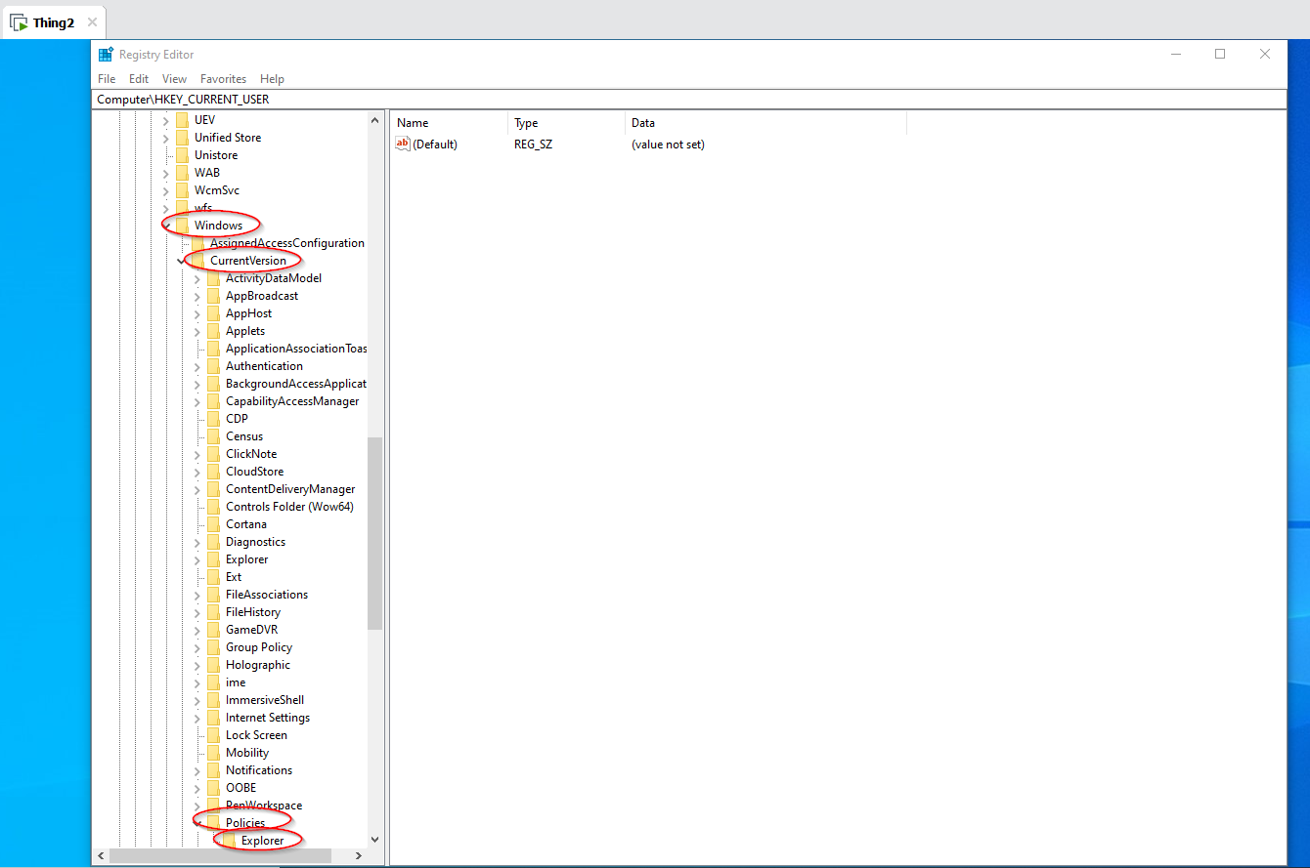

1. *Optional*: This step is only necessary if the Policies key (folder) does not contain an Explorer key (folder). In this case, you will have to create one by right-clicking on **Policies** 🡪 **New** 🡪 **Key**. Name the new key (folder) **Explorer.**

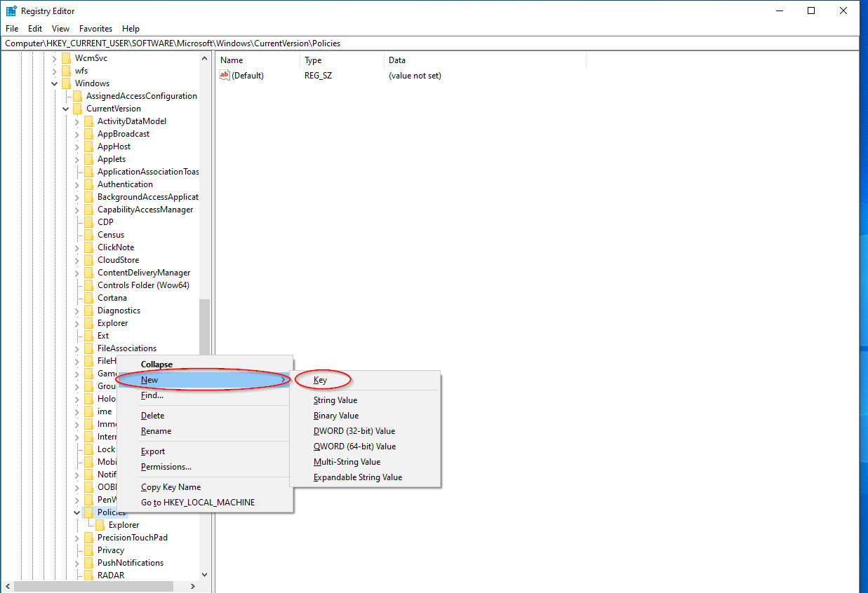

1. Once the Explorer folder has been opened, right-click anywhere within the blank space to the right-hand side of the window. Select **New**, then click

**DWORD (32-bit) Value:**

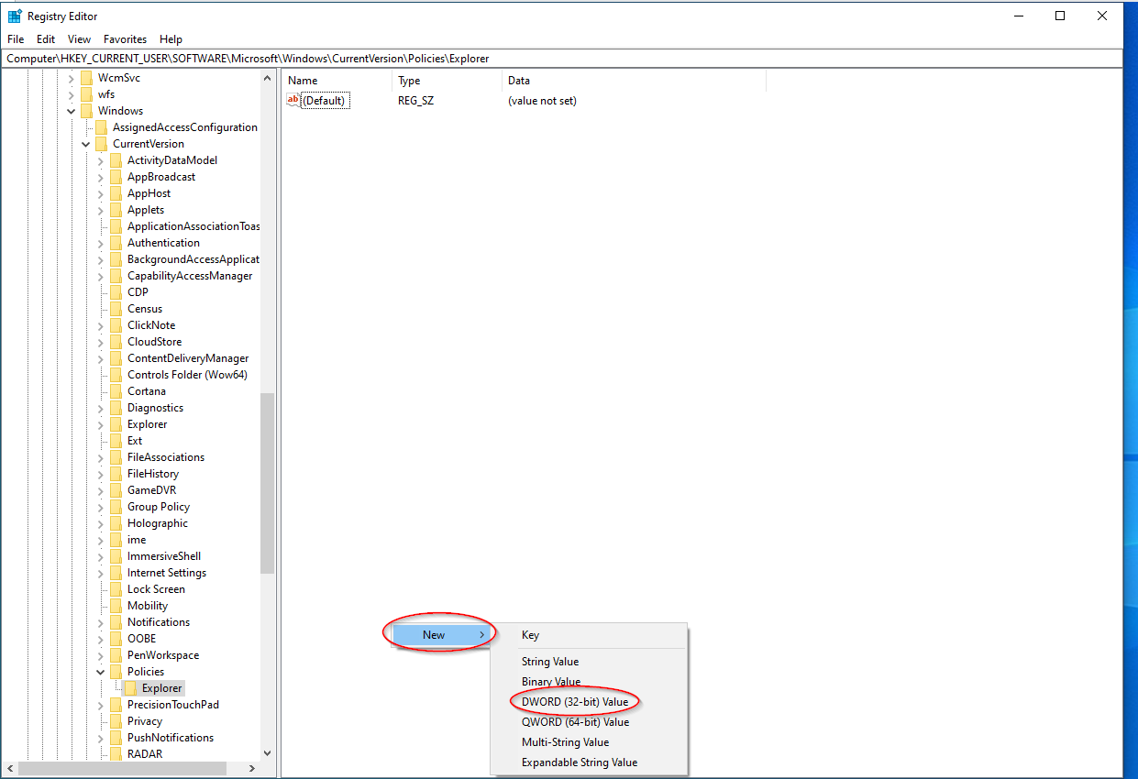

1. Rename this new DWORD value **ConfirmFileDelete** then hit the enter key:

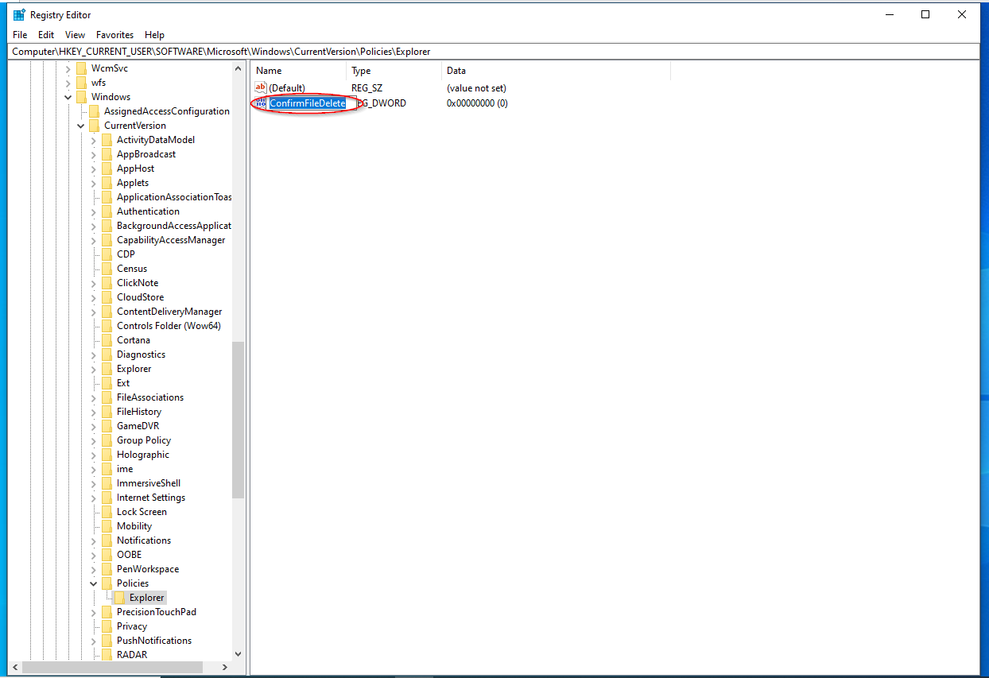

1. Double-click the newly renamed **ConfirmFileDelete** value and ensure its “Value data” field is set to **1**, then click **OK**:

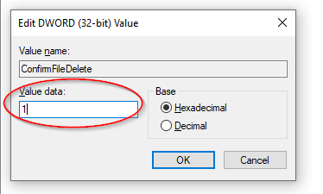

1. Close Registry Editor and restart the device.
2. Upon restart, right-click on the desktop then **New** 🡪 **Folder** to create a new folder. Right-click on the new folder and click **delete**. Confirm that the delete confirmation dialog box appears:

